Science TEKS: 3.11, 4.6, 5.1, 5.2, 5.3, 5.4, 5.5
Math TEKS: 5.11, 5.14, 5.15 Name: __________________________
Lesson Four:
The Dual Nature of Ozone: Stratospheric Ozone
What does it mean that ozone is “Good up high, Bad nearby”?
Can you think of another example of something that is good to have in one place, but bad to have somewhere else?
Overview. Ozone is a gas that is quite interesting because of its dual or “two-sided” nature. Ozone high up in the stratosphere naturally protects Earth from the Sun’s harmful ultraviolet light. However, ozone that forms close to the ground is a major air pollutant. This type of ozone can hurt humans and our surrounding environment.
Today, we will focus on the good ozone, which is called stratospheric ozone. You will learn a lot more about the “bad ozone” air pollution near the ground during Lesson Five.

Label the stratosphere, troposphere, and ozone layer in the diagram.
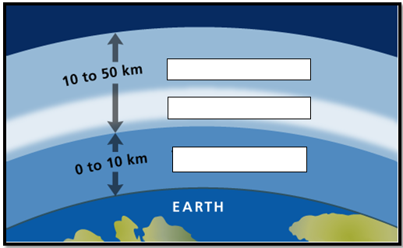

What did you learn about the ozone layer in the video?


How does the ozone layer protect life on Earth?
What chemicals damage “good” stratospheric ozone?
What has been done to preserve the ozone layer?

In the map that your teacher showed, where was the ozone hole?

